**Visual Studio Shortcut Setup**

**How to get to edit Visual Studio Shortcuts:**

1. Click on Tools > Options

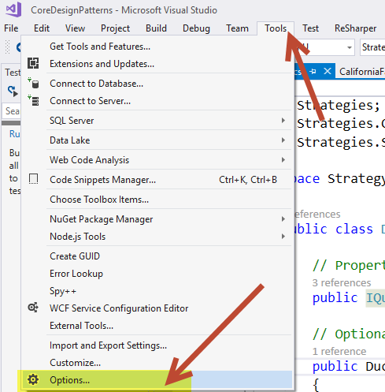

1. Under Environment, go to Keyboard. The highlighted section “Show commands containing:” corresponds to the “VS Mapping column” in the table that you will see next. If you press shortcut keys, you can assign a new shortcut to whichever command is selected. You can type in the shortcut keys to find out if it is used by anything currently by checking the box below that is greyed out in the screenshot that reads “Shortcut currently used by”, for ex. if you need to find the name of a shortcut you use, and you are not sure what it is called.

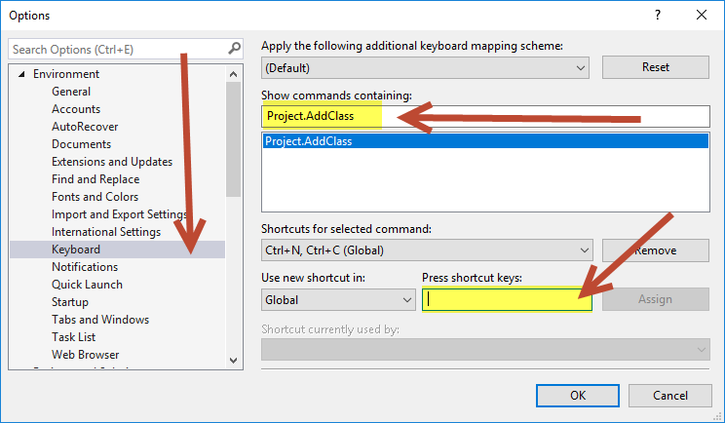

|  |  |  |  |  |
| --- | --- | --- | --- | --- |
| **Action** | **VS Mapping** | **Recommended Shortcut** | **How to remember it:** | **Default** |
| **Project / Files / References** |  |  |  |  |
| Add a new class | Project.AddClass | Ctrl + N, Ctrl + C | N for New and C for Class | N |
| Add new Project | File.AddNewProject | Ctrl + N, Ctrl + P | N for New and P for Project | N |
| Add existing Project | File.AddExistingProject | Ctrl + N, Ctrl + E | N for New and E for Existing | N |
| Set current project as startup | Project.SetasStartUpProject | Ctrl + S, Ctrl + P | S Set as Startup and P and Project | N |
| Add Reference to selected project | Project.AddReference | Ctrl + A, Ctrl + R | A for Add and R for Reference | N |
| **Code Related** |  |  |  |  |
| Comment out code | Edit.CommentSelection | Ctrl + K, Ctrl + C |  | Y |
| Comment in code | Edit.UncommentSelection | Ctrl + K, Ctrl + U |  | Y |
| Collapse all methods | Edit.CollapsetoDefinitions | Ctrl + M, Ctrl + O |  | Y |
| Collapse all code | Edit.ToggleAllOutlining | Ctrl + M, Ctrl + L |  | Y |
| Uncollapse all code | Edit.StopOutlining | Ctrl + M, Ctrl + P |  | Y |
| Rename all | Refactor.Rename | Ctrl + R, Ctrl + R |  | Y |
| Fix all code alignment | Edit.FormatDocument | Ctrl + K, Ctrl + D |  | Y |
| Commenting template |  | /// the line above what you want to comment, then hit enter |  | Y |
| **Navigational** |  |  |  |  |
| Go to Declaration | Edit.GoToDeclaration | F12 |  | Y |
| Go to Implementation | Edit.GoToImplementation | Ctrl + F12 |  | Y |
| Navigate To | ReSharper VS config default | Ctrl + T |  | Y |
| Go to Solution Explorer | View.SolutionExplorer | Ctrl + S, Ctrl + E | S for Solution and E for Explorer | N |
| Go to Team Explorer | View.TfsTeamExplorer | Ctrl + T, Ctrl + E | T for Team and E for Explorer | N |
| Go to Test Explorer | TestExplorer.Show. TestExplorer | Ctrl + U, Ctrl + T | U for Unit and T for Tests | N |
| Previous page | View.NavigateBackward | Ctrl + - |  | Y |
| Forward page | View.NavigateForward | Ctrl + Shift + - |  | Y |

**How to export Visual Studio Shortcuts:**

1. Click Tools > Import and Export Settings ….

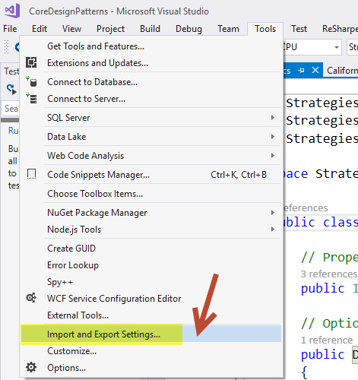

1. On the popup, choose Export selected environment settings and hit Next >
2. To choose only the keyboard settings, UNCHECK all settings, then go under options, go under environment, and then CHECK keyboard.

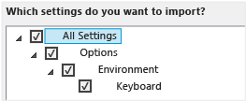

**How to import Visual Studio Shortcuts:**

1. Go to the same menu from Tools > Import and Export Settings …
2. Choose Import selected environment settings then hit Next >
3. Select if you just want certain settings or all the settings, for Keyboard go to the same mapping as the screenshot above in the previous set of instructions.
4. Choose the.vssettings file you want to import and where you want it stored.
5. Hit Finish

**How to set new classes to be public by default:**

1. Go to one of these locations, depending on which version of VS you own.

* VS2015: C:\Program Files (x86)\Microsoft Visual Studio 14.0\Common7\IDE\ItemTemplates\CSharp\Code\1033\Class
* VS2017(RC): C:\Program Files (x86)\Microsoft Visual Studio\2017\Enterprise\Common7\IDE\ItemTemplates\CSharp\Code\1033\Class

1. Edit the template and add the public keyword before class. Add any other changes you would like to a default class or its usings.

ReSharper Configurations

* ReSharper feature set vs VS2017: <https://www.jetbrains.com/resharper/documentation/comparisonMatrix_R2017_2_vs2017.html>
* ReSharper full customization guide: <https://confluence.jetbrains.com/display/NETCOM/ReSharper+Customization+Guide>

**Remove unused usings:**

Click on an unused using and hit the lightbulb to have the option to remove. Can choose to remove from file or full solution.

**ReSharper Code Cleanup: Can run a code cleanup on your full page**

Ctrl + E, Ctrl + C

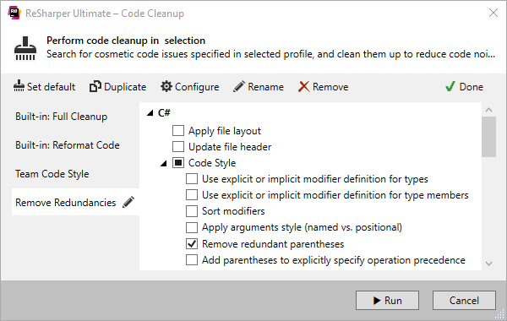

**Implicit/Explicit named types or var consistency:**

1. Put your typed cursor over var, click the tool shaped icon to the left, choose whether you want the type specified explicitly everywhere or in a certain area. Do it to a var to get the option to change everything to explicit. Do it to a Type to have the option to change it to var.

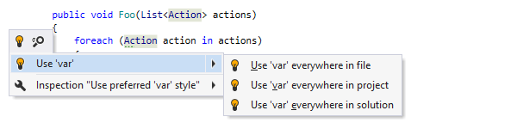

**ReSharper Complete Statement**: This feature inserts necessary syntax elements (braces, semicolons etc.) and sets you in position to start the next statement, saving you from excessive juggling with the caret.

Ctrl + Shift + Enter

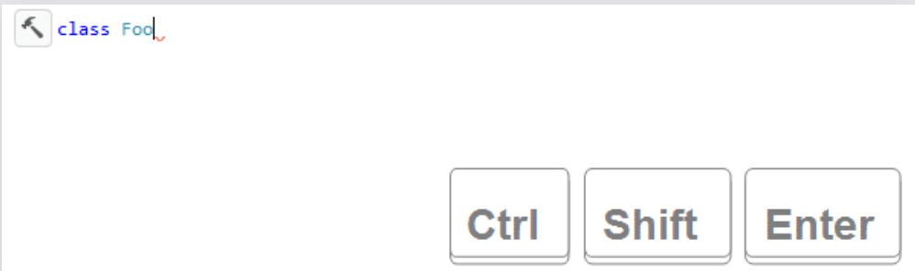

ReSharper Regex tool: If you put your cursor within the brackets, and hit Alt + Enter then choose Validate Regular Expression, you can test out sample data to your Regex.

Regex reg = new Regex("[a-z]");

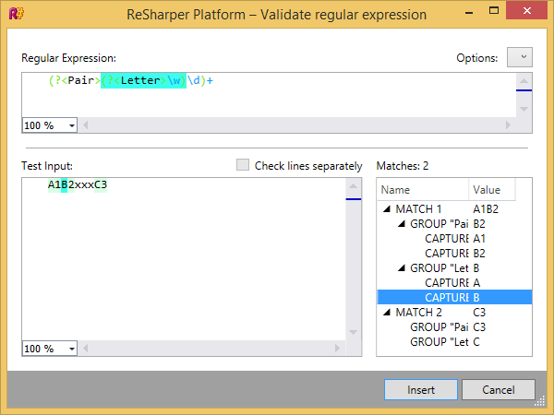

ReSharper Live Templates: You can preset code that will automatically generate for you based on typing in a shortcut!

* ReSharper > Tools > TemplateExplorer

Try typing one of the below then hitting Tab or Enter afterwards:

* nguid
* itar

ReSharper Shared Settings: <https://www.jetbrains.com/help/resharper/Sharing_Configuration_Options.html>

Code Commenting Tool:

GhostDoc Community (free) for VS2017: <https://marketplace.visualstudio.com/items?itemName=sergeb.GhostDoc>

GhostDoc Pro/Enterprise/Community for VS2015: <https://submain.com/download/ghostdoc/pro/>

Cost of Pro/Enterprise editions: <https://submain.com/order.aspx>

Features for different editions: <https://submain.com/products/ghostdoc.aspx#features>

*Note Pro/Enterprise come with free spell checking 😊

4-minute kick-starter tutorial: <https://submain.com/ghostdoc/GettingStarted/>

Spelling Check Tool: ReSpeller (free!)

If you don’t get GhostDoc’s paid versions and you want free spelling tools you can get it from the folks at IntelliJ who made ReSharper by downloading this:

<https://resharper-plugins.jetbrains.com/packages/EtherealCode.ReSpeller/>